**1 Introduction**

**1.1 Referenced documents**

List all documents (specifications, standards, journal articles, text books) useful to help understand the current document.

• Teja PS. Design of radix-8 booth multiplier using koggestone adder for high speed Arithmetic applications.

Emerging Trends in Electrical, Electronics Instrumentation Engineering: An international

Journal (EEIEJ). 2014 Feb;1(1):45-55.

• K. Sindhuja, C. Thiruvenkatesan, 2017, Design of Low Power Approximate Radix-8 Booth Multiplier,

INTERNATIONAL JOURNAL OF ENGINEERING RESEARCH TECHNOLOGY (IJERT) RTICCT

– 2017 (Volume 5 – Issue 17)

**1.2 Design library name**

Give library name; adhere

UMC65LLSC

**1.3 People involved in the block**

Please list all people involved in the design

Akshat Mathur (2023EEN2223)

**2 Function**

**2.1 Brief overview**

Give functional and electrical specifications of the design. Specify all inputs, processes (controls and algorithms) and outputs. Describe all relevant concepts and assumptions/limitations. All descriptions in bulleted points

Multiplication Accumulator multiplies the input data optimally and stores that value in accumulator, with subsequent data inputs the preexisting data in the accumulator is added with the new multiplication output.

Multiplication algorithm used is RADIX -8 Booth Algorithm. And pipelining has been introduced at Partial product and multiplication stages

1. OP code generator

From the multiplier (A) certain bits are extracted with form op codes.

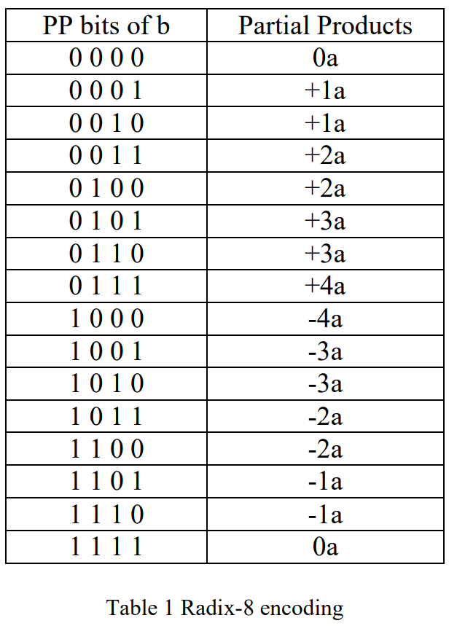

1. PP generator

This partial product generator, based on values from op codes generates Partial products using the multiplicand (B).

1. Driving logic

Based on spec, the data is truncated and rounded off to 27 bits before driving to output.

**2.2 Interfaces**

Include a table showing all the ports associated with this block; the table should have the following information:

● Group signals with a common interface together.

● Indicate bus ranges as part of the signal name, for example DATATOPERIPH <15:0>.

**Signal name I/O Description Logical grouping**

name of the signal, as it input/output brief description eg: peripheral access, link

appears on the opus interface control

symbol

**eg. SIGNAL** <a:b>

|  |  |  |
| --- | --- | --- |
| Signal Name | I/O | Description |
| clk | Input | Global clock |
| rst | Input | Global reset |
| [15:0]A | Input | multiplier Data signal |
| [15:0]B | Input | multiplicand Input Data signal |
| [26:0] out | Output | Accumulator output |

Table1 : Input Output signal and description

**2.3 Architecture**

Include a diagram showing the conceptual split of the functions of the block (this is not necessarily the same as the actual logical or physical implementation) to illustrate.

The Basic architecture of MAC is as follows.



Fig1 : Basic MAC architecture

**2.4 Detailed functional description**

Include a detailed description of what the block does, using the functional split in the Architecture diagram to aid the description. The information should be sufficient to allow a chip integrator to connect it into a higher level of design hierarchy, and a verifier to establish what the testing/verification requirements of the block are.

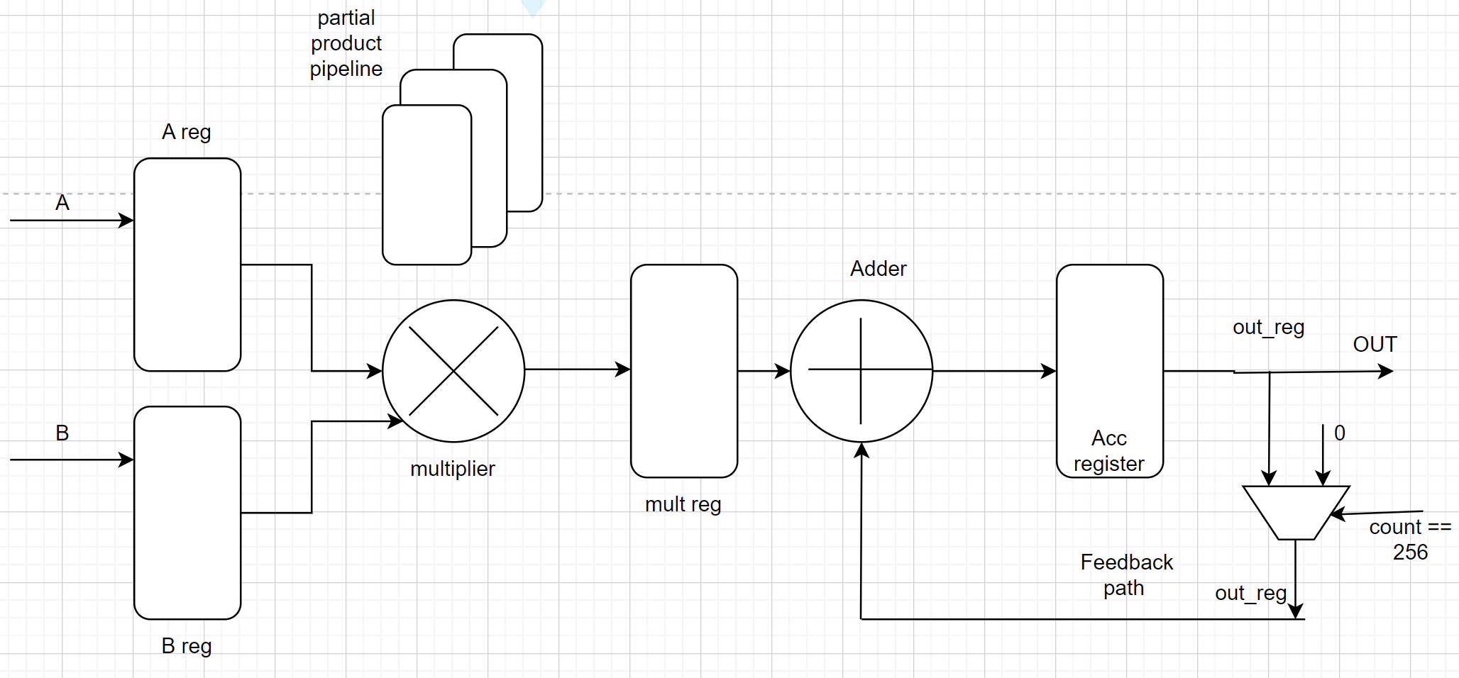

Fig2 : MAC architecture used

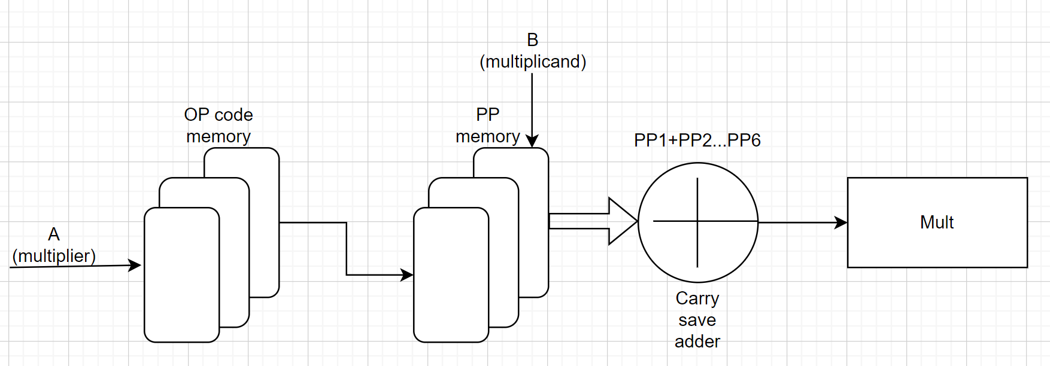

Fig3 : Multiplier block architecture

**3 Design parameters**

Specify all design parameters which are closely linked with the functional requirements of the block.

1. Input = 16 bits
2. Output = 27 bits

**3.1 Performance Requirements**

State performance parameters, for example:

● speed/bandwidth requirements

● memory requirements

● latency limits,

Required Clock frequency = 150Mhz (6.66ns)

**3.2 Clock Distribution**

Documentation must include:

Parameters such as frequency, duty cycle, rise and fall edge characteristics, active edge clock edge, clock skew constraints, where applicable.

Required Clock frequency = 150Mhz (6.66ns)

Sdc command

create_clock clk -period 6.66 -waveform {0 3.33}



**3.3 Reset**

Describe hardware/software resets and their polarity. Include input/output values at

reset.

Reset used = Synchronous reset, Active high

**3.4 Timing Description**

The following information must be included:

● latency,

● update conditions,

● re-timing (low power and normal modes),

● direct path to flip-flop.

Retiming was enabled during optimization

**4 Verification Strategy**

**4.1 Objectives**

Briefly describe the design (the name and its main functionality) and the kind of approach you intend to use (dynamic verification, property-checking, emulation, if the environment is completely new or it is a porting from an existing one and any other relevant details).

1. For RTL Verification

A comprehensive testbench was generated using SystemVerilog

The verification was done using Constrained randomization for better coverage.

For Ex:

rst=0; $urandom_range('h1111, 'hBBBB); B=$urandom_range('h2222, 'h5555);

Trailing bits verification strategy is also used to check for stuck at zero issues.

For Ex:

#31 rst=0; A='hFFFF; B='h1111;

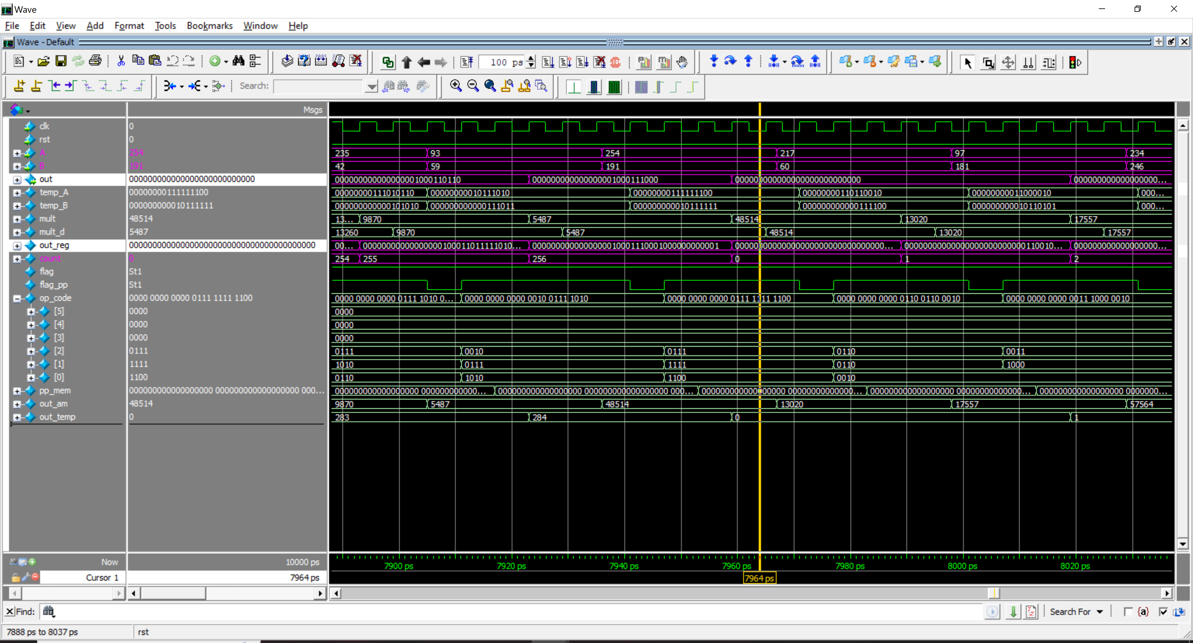

Fig4: Waveform showing the correct counter functionality

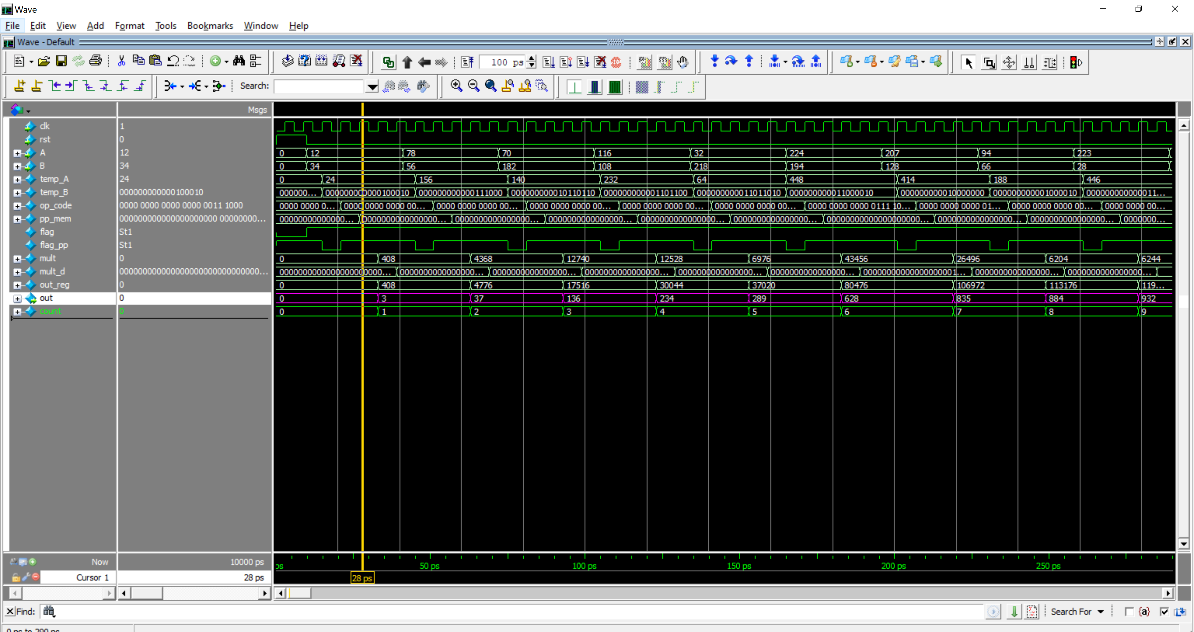

Fig5: Waveform of RTL Verification

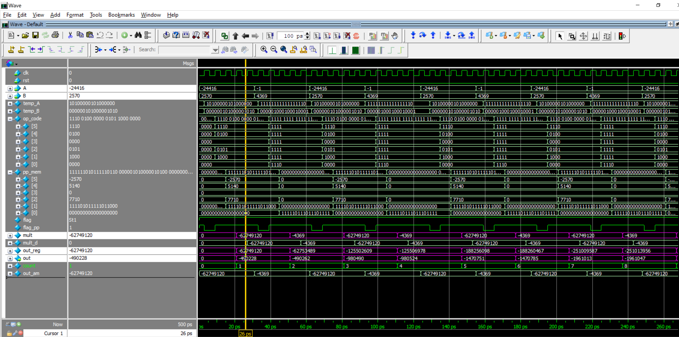

Fig6: Waveform of -ve numbers.

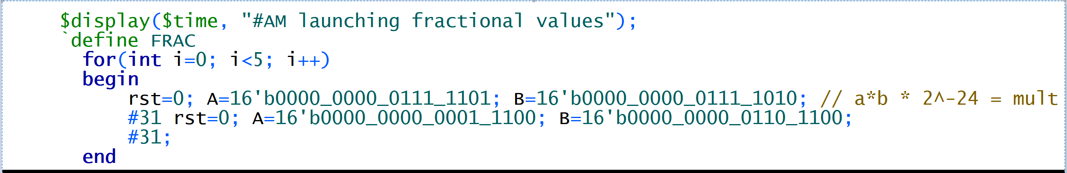

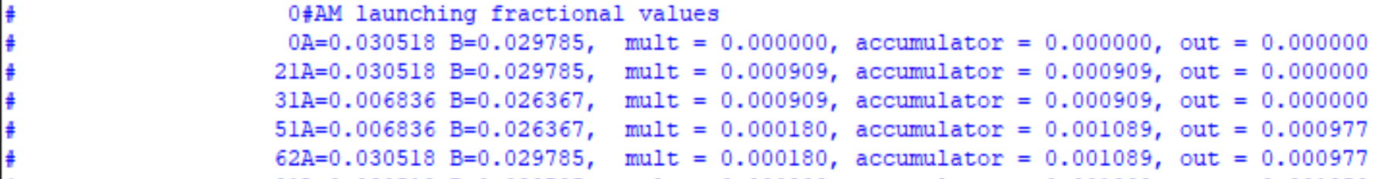

Fig: Fraction values

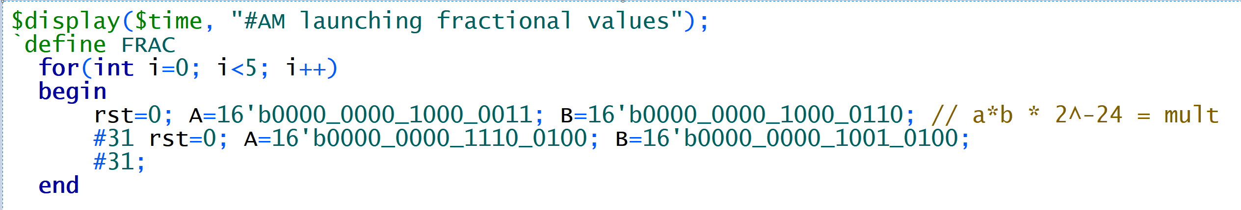

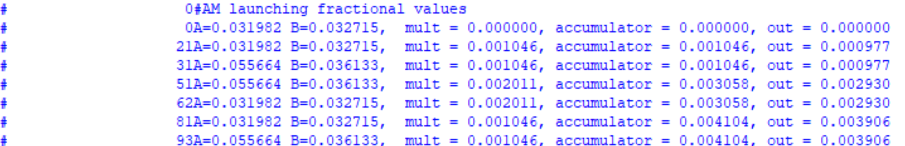

Fig: Fractional -ve numbers

1. After Layout

DRC verify was run to check for any DRC issues.

**4.2 Tools and Version**

Include a brief description of the tools that you plan to use to verify the design, only specifying versions of the tools at the report stage:

_ environment

_ simulator

_ coverage

_ verification support tools

_ memory models

_ compilers/software toolchain

1. Siemens EDA ModelSim 10.5b
2. Cadence Genus 19.12-s121_1
3. Cadence Innovus

**4.3 Checking mechanisms**

Explain the checking method that you plan to adopt. You should usually say you want to have some sort of self-checking mechanism in place, so that every test is able to report a failure or a success. Just for some (few) cases it could be possible to explain that the visual check of the waveforms had to be used because it was impossible (or too difficult) to put in place a self-checking mechanism. Planning of non self-check tests has obviously to be explicitly agreed with the reviewers and must be highlighted in both the document and the environment.

1. For RTL Verification

A comprehensive testbench was generated using SystemVerilog

The verification was done using Constrained randomization for better coverage.

1. $monitor statement was used to print the data both for fraction and integer values and to check manually

Plan:

Implement self checking mechanism

**5 Functional Checklist**

**Briefly** list the main functionality of the design that has to be checked, from a logical point of view:

_ interfaces (internal, among blocks, and external, with the testbench),

_ protocols (examples: PCI, MPX),

_ registers (example: “it is possible to write WO registers, to read RO registers and to read and

write R/W registers”),

_ interrupts (we ensure that all the interrupts are raised),

_ timings (example: for clock ratios and asynchronous protocols),

_ other functions.

This functionality will be detailed in following sub sections.

Main functionality tested

1. OP Code generation – Correct bits were taken from the multiplier to form op code memory – CHECKED.
2. PP generation – Based on the corresponding op code, correct Partial product was generated for addition - CHECKED.
3. Multiplication: The partial products need to be added correctly in order to obtain correct mult output – CHECKED
4. Accumulator operation – The multiplication data is being accumulated and added with previous data in the accumulator – CHECKED.
5. Counter functionality – on counter achieving 256 the accumulator is reset - CHECKED.
6. Truncation and rounding off of Output – Correct bits are truncated, rounded off and sent to output wire. - CHECKED

**5 Testbench**

**5.1 Overview**

In this section give a brief explanation of the testbench specification, whether it will use a golden model or not (like COWARE models). Avoid going into many technical

implementation details, which could be changed during the verification. This is also the place to highlight eventual criticality (complex harness to be verified stand-alone).

1. For RTL Verification

A comprehensive testbench was generated using SystemVerilog

The verification was done using Constrained randomization for better coverage.

1. $monitor statement was used to print the data and to check manually

**5.2 Architecture**

At the plan stage explain briefly how do you plan to design your testbench.

It should contain the design under test (DUT) and a number of harnesses and processes.

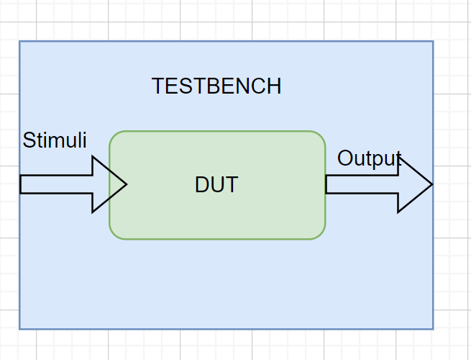

Fig7 : Testbench architecture

**6 Tests Specification**

List and describe here the functional tests you are going to design.

_ Detail here all the tests suite with just a brief description for the tests

1. Constrained randomized tests
2. Unsigned
3. Signed
4. Trailing bits to check for stuck at 0/1 issues.
5. Fractional values

**7 Design Microarchitecture**

*Insert diagram here showing the actual logical design partitioning chosen to meet the functional specification given in associated documentation and listed in the references section above.*

**7.1 Top Level Interface**

All top-level interfaces are listed and described in the functional specification given in associated documentation and listed in the references section above. Please refer the reader to that rather than duplicate the information here - it is more of a maintenance overhead to keep multiple copies of the same information up-to-date.



Fig8: MAC architecture used

**7.2 Sub-Block Description**

Name each sub-block required by the overall design:

For every sub-block, describe logical implementation; use of diagrams of hierarchical partitioning, tables of interface listings, state machine and flow diagrams etc. where appropriate.

Give details of implementation choices. Consider, for example:

datapath, standard cell

embedded macros e.g. memories, FIFOs, CAMs

asynchronous (inter-clock) design

clock gating

reset circuitry

low power control

special DFT implementation techniques

any non-standard design circuits or techniques.



Fig9 : Multiplier block architecture used

**7.3 Structural Mapping Process**

Describe the process for converting from RTL to gate-level representation of the design including:

logical or physical synthesis

testability insertion and analysis

formal proof that RTL and netlist correspond

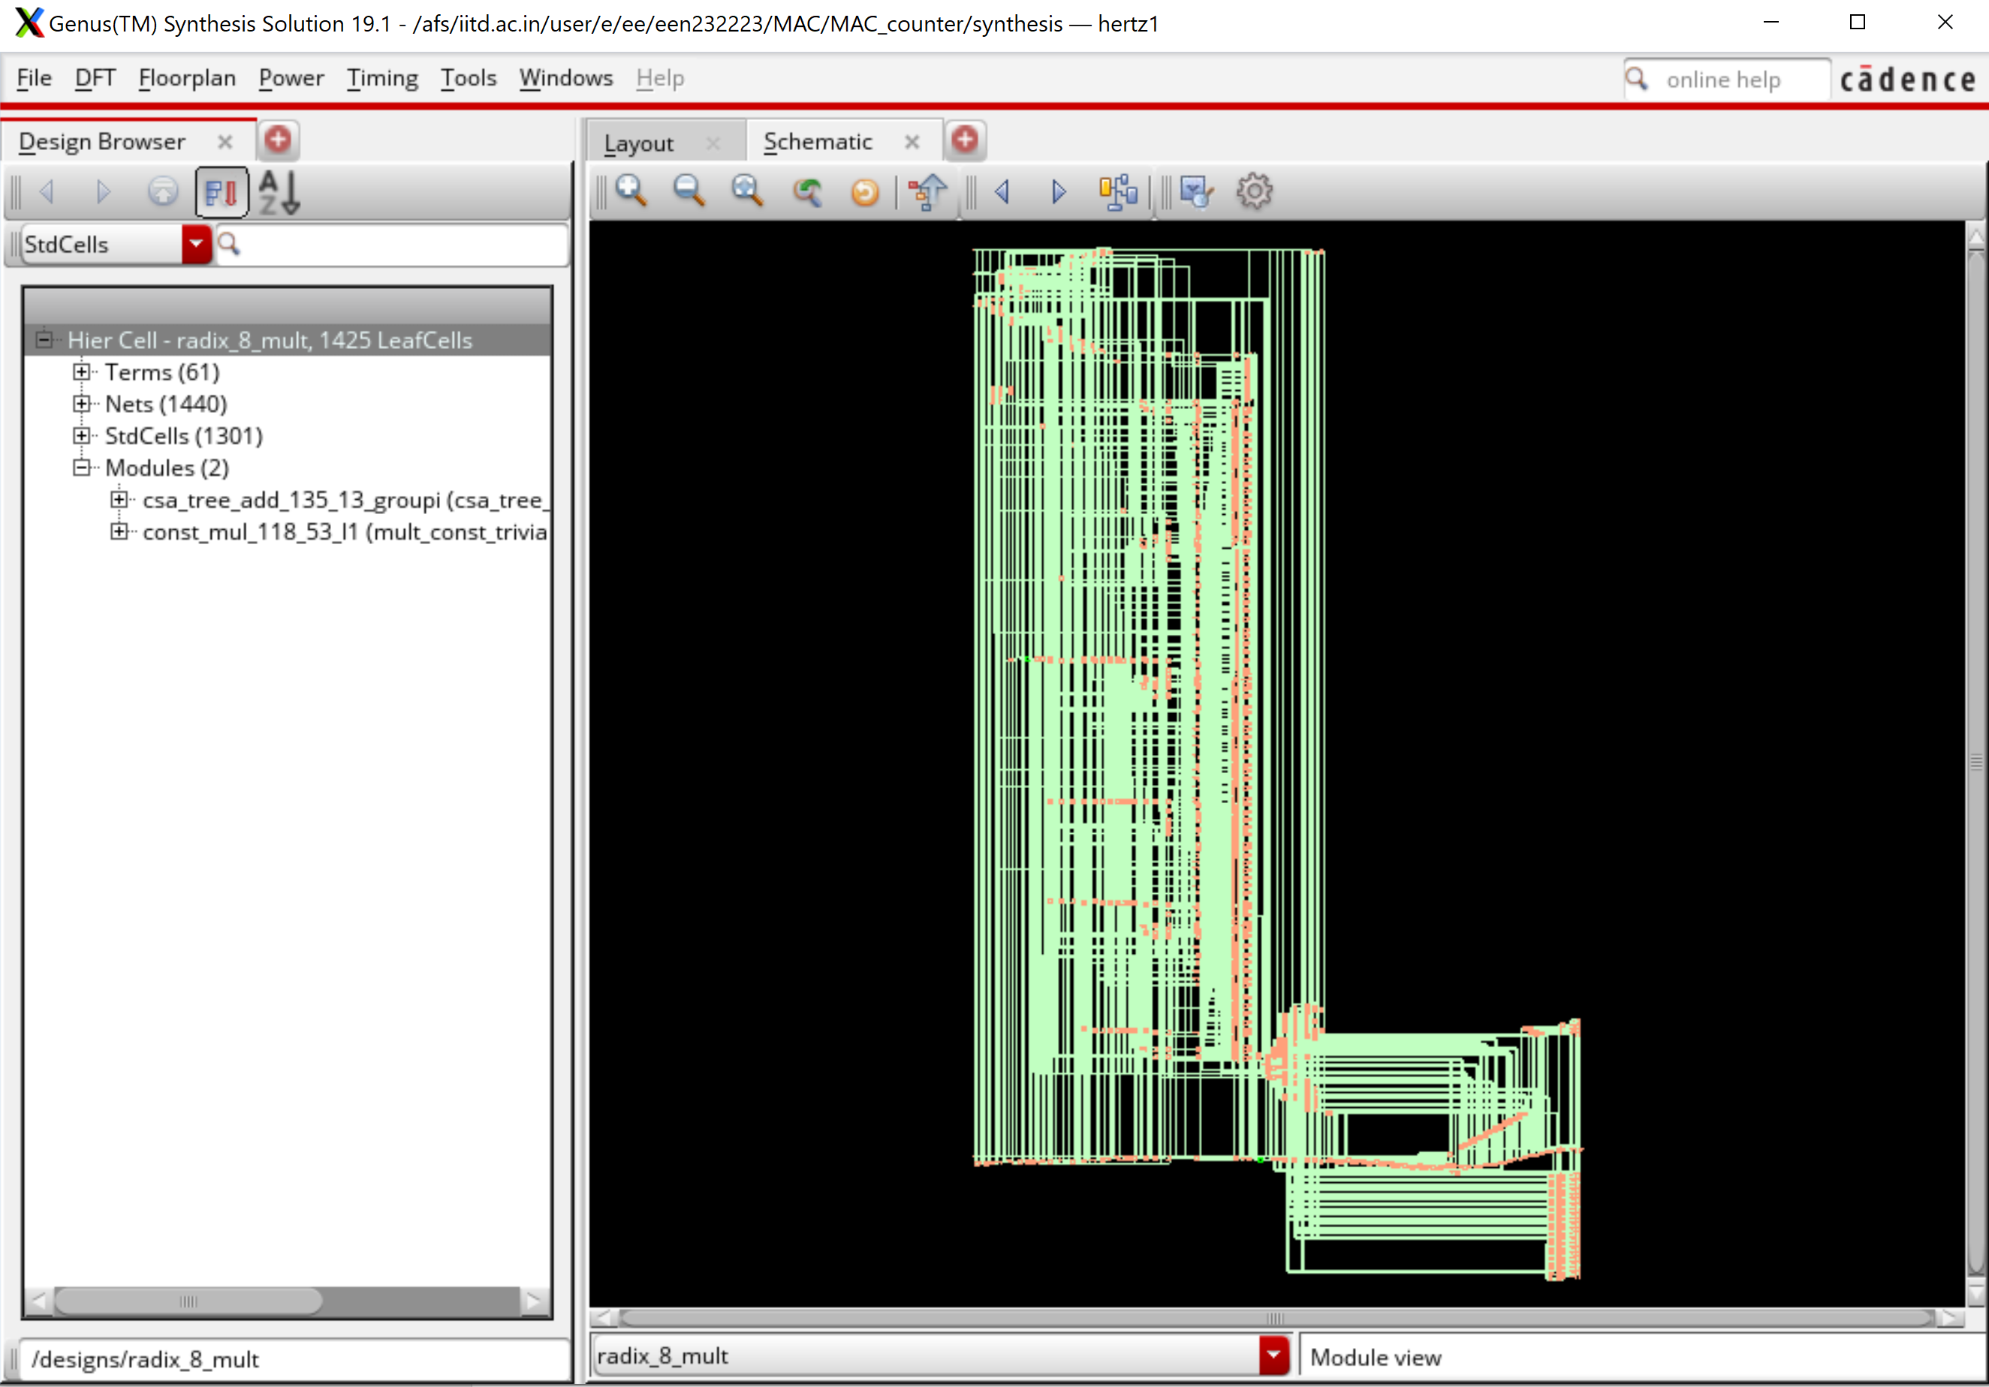

Fig10 : Gate level netlist

**8 Physical hierarchy**

**8.1 Floorplanning**

Insert a “plot” here showing the actual floorplan and physical partitioning chosen to meet the design requirements described in Section Design Microarchitecture.

Please give details of abstract size, shape, aspect ratio of dimensions, pin placement criteria, specific placement of hard macros such as RAMs, FIFOs etc., special cell site information or channel routing criteriarequired to resolve layout hot-spots, any special pre-routing of power, critical signals and so on.

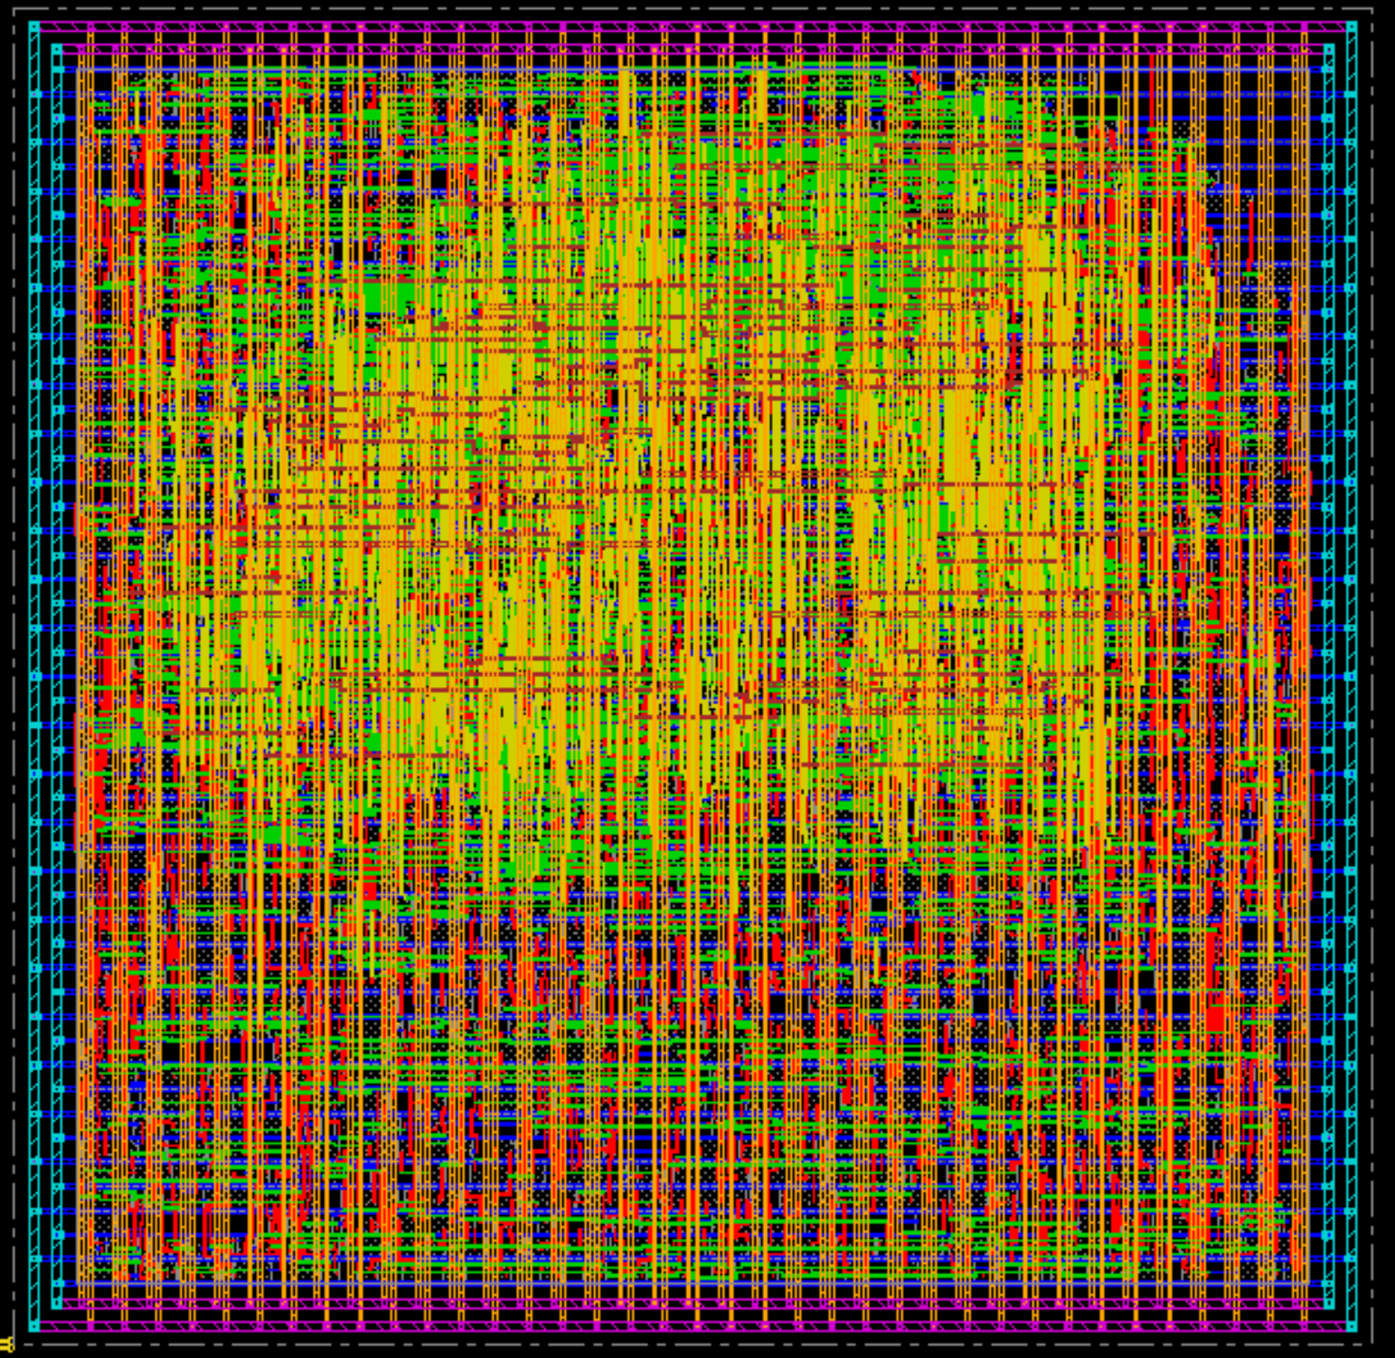

Fig11 : Post Layout design

**8.2 Clocktree insertion**

Describe here and through reference to the associated functional specification as referenced in Section 7.1: details of the clock strategy and constraints (levels of clock buffering, clock skew and insertion delay targets), relationships between clock domains (if any) and so on.

**8.3 Layout Strategy**

Describe, either directly here or by reference to a standard methodology document, the process used to go from delivered netlist to completed and verified layout.

Please give details on:

physical constraints applied

placement e.g. standard P&R QPlace, Physical Synthesis (or Compilation) etc.

routing e.g. standard, timing driven, cross-talk avoidance etc.

physical verification

generating and delivering extracted parasitics for timing and electrical checking.

**9 Results**

The purpose of this section is to provide a potential re-user with enough information to determine whether this implementation (as opposed to other implementations) of the block is suitable for their needs; as such, the content should be restricted to the key figures, only giving details where the block does not meet the specification. Do not copy large files and reports into the document; simply highlight or explain areas of

importance.

**9.1 Area**

Give the following information for the block (and its sub-blocks, if relevant); if no layout exists for the block put “N/A” in the last 3 columns.

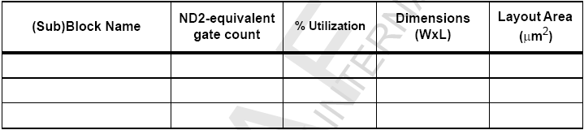

|  |  |  |  |
| --- | --- | --- | --- |
| Depth | Name | #Inst | Area(um^2) |
| 0 | radix_8_mult | 1404 | 5418.36 |
| 1 | csa_tree_add_136_13_groupi | 198 | 806.76 |
| 1 | const_mul_112_53_I1 | 17 | 110.88 |
|  |  |  |  |

Table3: Post CTS Area

**10.2 Timing**

This section should indicate whether the block meets its timing constraints and how close it is to the original specification. If any constraints are not met, describe them and explain why they have been signed off; describe possible options for speed-up should the block be re-engineered.

Give the cycle time and clock skew of the block.

|  |  |
| --- | --- |
| Design | Slack |
| Post Synth | **2.929ns** |
| Pre-CTS - setup | **0.009ns** |
| Pre-CTS - hold | **-0.009 ns** (within 30% range) |
| Post-CTS - setup | **0.021ns** |
| Post-CTS - hold | **-0.009 ns**  (within 30% range) |

Table2 : Timing numbers

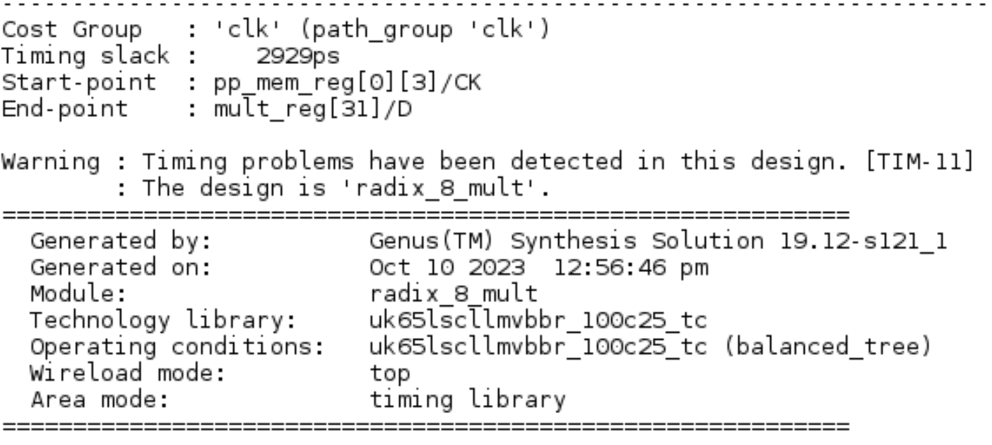

Fig: Post Synth Slack snippet

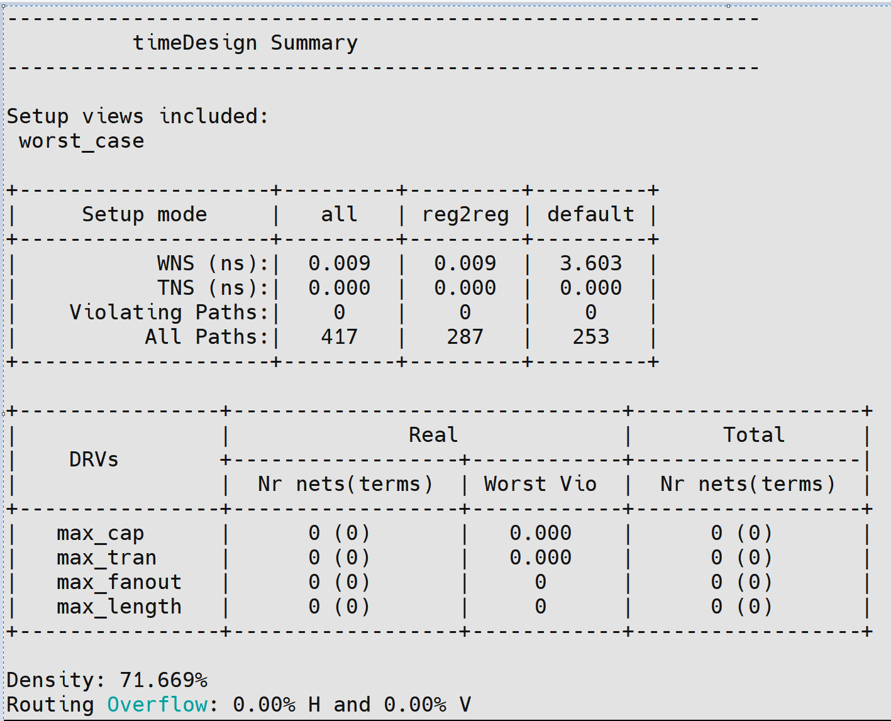

Fig: Pre CTS setup time snippet

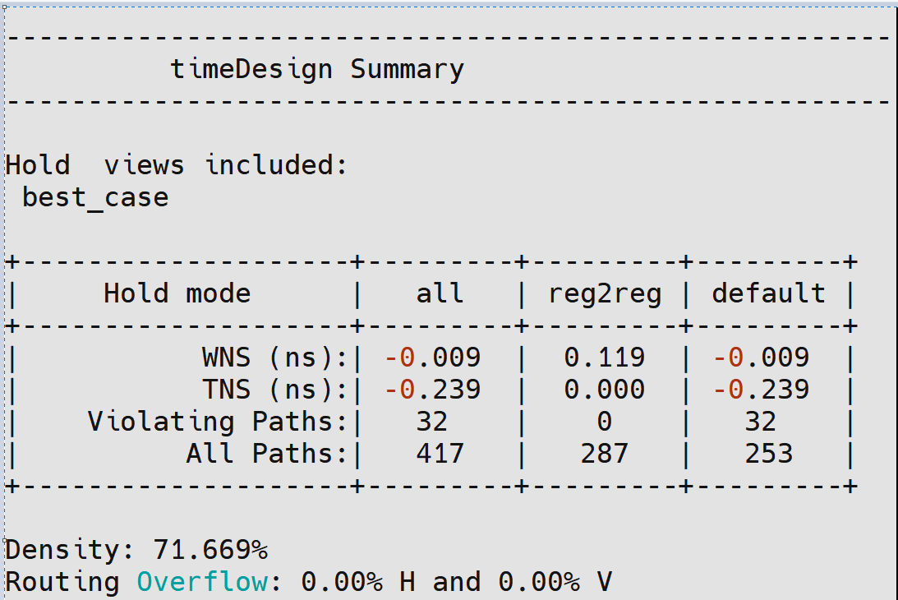

Fig: Pre CTS hold time snippet

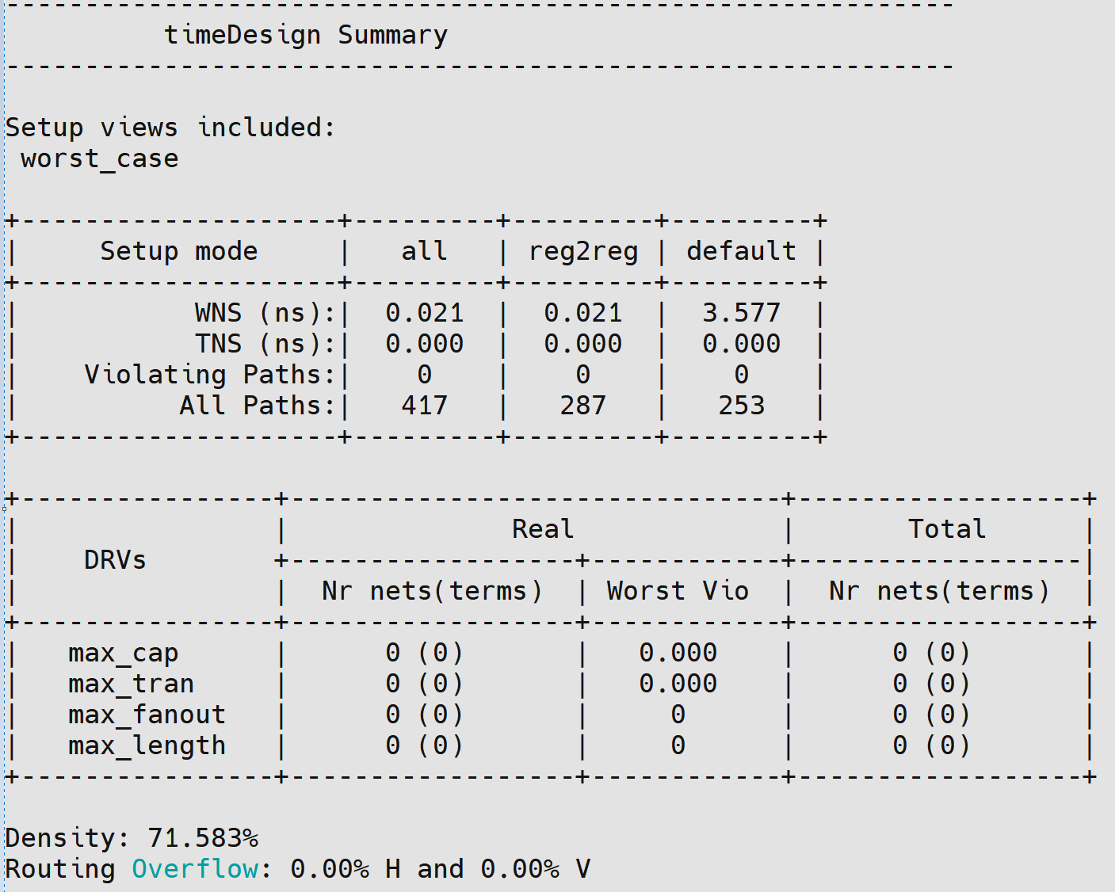

Fig: Post CTS setup time snippet

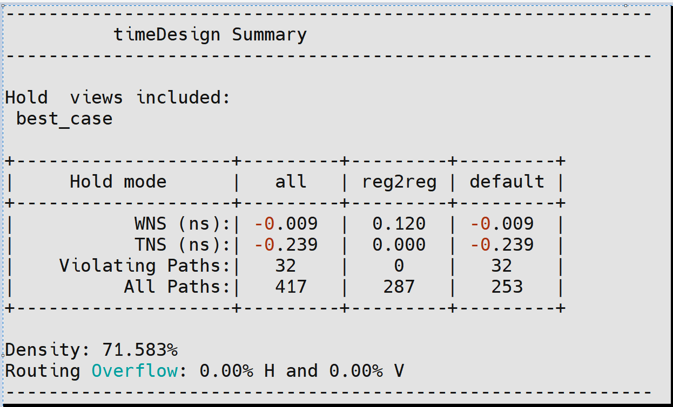

Fig: Post CTS Hold time snippet

**POWER UTILIZATION**

|  |  |  |
| --- | --- | --- |
| Total Internal Power: | 0.22407079 | 71.9445% |
| Total Switching Power: | 0.08634351 | 27.7231% |
| Total Leakage Power: | 0.00103526 | 0.3324% |
| Total Power: | 0.31144956 |  |

Table3: Post CTS Power utilization

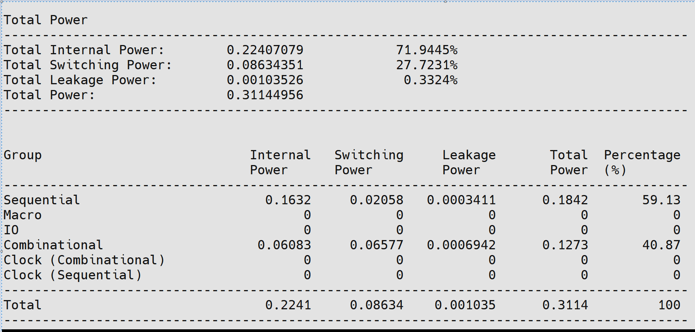

Fig: Post CTS Power Utilization snippet

**10.3 Testability analysis**

**Test signals**

List all test signals used for this block

*Note: this includes signals regarded as a “clock”, e.g. reset and actual clocks.*

**10.4 DRC rule violations**

List any DRC rule violations and explain why they have been retained.

DRC VIOLATIONS – NONE

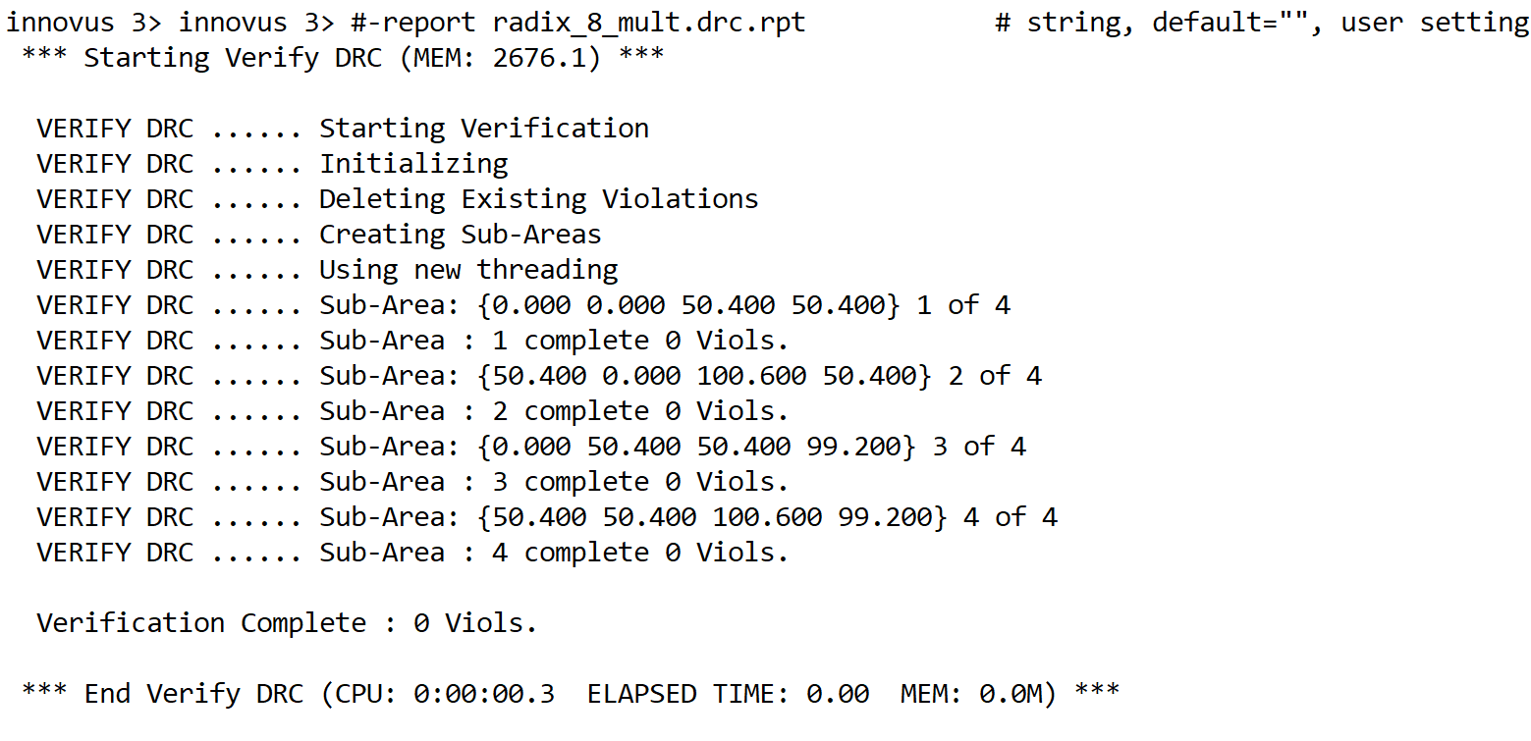

Fig12: DRC clean

**11 Bugs known at submission date**

**NONE**